Name ____________________________________ Date _____________ Class Period _______
“Food Felons” Suspect List
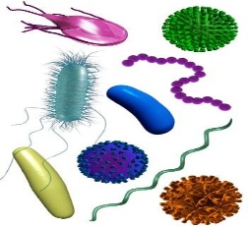

Suspect Name | Signature (Signs/Symptoms) | Food Sources | Prevention
Bobby Botulism
(Clostridium Botulinum)
Sara Salmonella
(Salmonella)
Eerie E. Coli
(Escherichia coli)
Stanley Staph
(Staphylococcus)
Lisa Listeria
(Listeria)
Carl Campylobacter
(Campylobacter jejuni)
Cliff Clostridium
(Clostridium perfringens)

